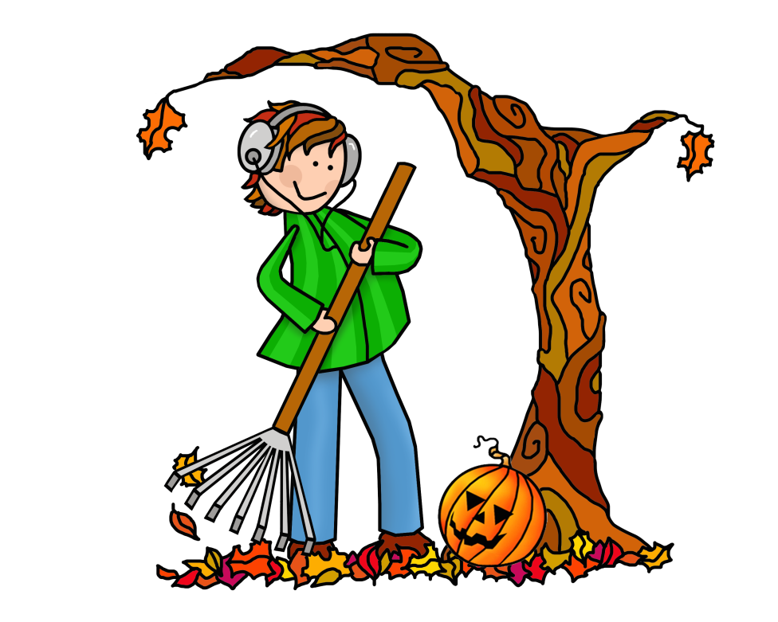

November Events
BOOKED FOR LUNCH
Monday, November 20 @ 11:30 am

ADULT COLORING PARTY
Monday, November 20 @ 6:00 pm

CLOSED FOR THANKSGIVING
November 22, 23, 24

TECH SOUP
Wednesday, November 29 @ 1:00 pm

