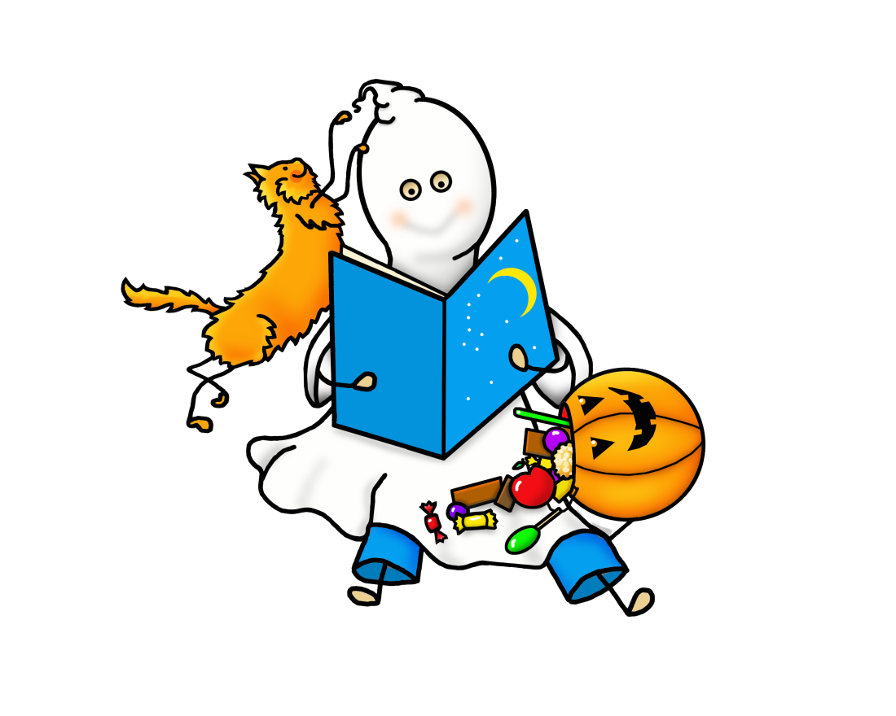
October
Events
STORYTIME
Wednesday, October 4 @ 1:30 pm
BOOKED FOR LUNCH
Thursday, October 12 @ 11:30 am
ADULT COLORING PARTY
Monday, October 16 @ 6:00 pm
AUTHOR PROGRAM
Tuesday, October 24 @ 7:00 pm
TECH SOUP
Wednesday, October 25 @ 1:00 pm
BOOK FAIR
October 30 – November 3

