Mobile Printing Now Available

With our new MobilePrint Service™, you can use your personal computer or mobile device to print to the library’s printers from anywhere. Simply submit documents for printing and come to the library to pick up and pay for your document. Password protected sites and documents will not print.

How to print from a laptop or desktop computer at home or work:

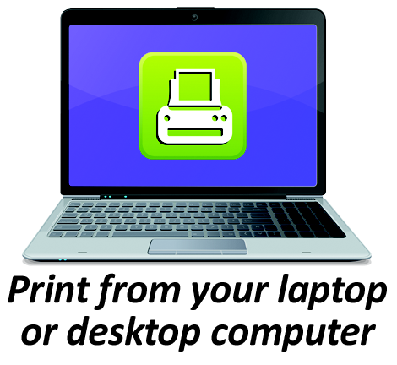
- Begin by visiting https://www.printeron.net/hlc/collingsworth .
- Select the printer and enter your email address.
- Browse your computer to find and select the file you wish to print.
- Click the green print icon (you will see the status of your print job and a reference number).
- At the Library give the staff the email address you sent from and they will release your print jobs. Your print job will be printed!

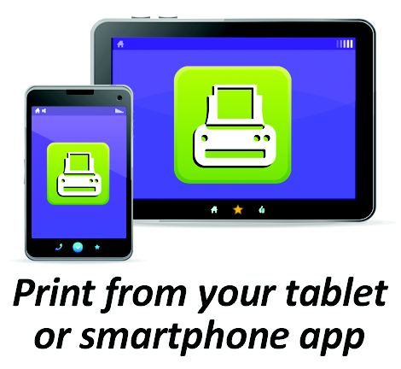
How to print from tablet or smartphone app:

- Visit your device’s ‘store’ for apps, install and launch the PrinterOn App.
- Click “No printer selected”.
- Click “Search”. Search for Collingsworth.
- Find Collingsworth Public Library and click black and white and save. Or click color and save
- To print:
  - Documents: when viewing the document, click in the upper right corner and upload the document to the PrinterOn App.
  - Photos from your phone: open the app, click on “photo” and select a photo to print.
  - Select the printer and click the print icon.
  - Enter an email address and click on the check mark (you will receive a notice that the job started, and shortly after another message stating “Job Success”).
  - At the Library give the staff the email address you sent from and they will release your print jobs. Your print job will be printed!

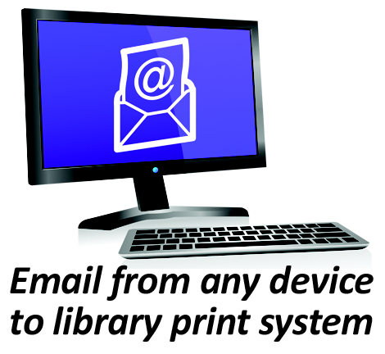
How to use email to send something directly to library print system:

- Email from any device directly to the library’s print system at
hlc-collingsworth-bw@printspots.com for black and white. For color email to hlc-collingsworth-color@printspots.com
- At the Library give the staff the email address you sent from and they will release your print jobs. Your print job will be printed!

REMEMBER! The library only accepts cash for print jobs. Customers may not bring in their own paper for printing documents due to possible printer jams or confusion with the printer queue. Print jobs are held for 24 hours after which they are permanently deleted. Also, the Library is closed on Saturday and Sunday.

Call 806-447-3183 if you have any questions.

